Reinhilde Jacobs – short personal CV

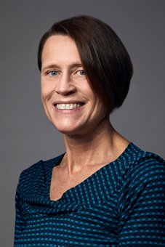
Reinhilde Jacobs is dentist, Doctor in Dental Sciences (PhD University of Leuven), periodontologist (KU Leuven) and Master in Dental Radiology (University of London). She is full professor at the University of Leuven and visiting professor at Karolinksa Institutet, Stockholm, Sweden and the Dalian Medical University in China. R. Jacobs is heading the omfs impath research group of the KU Leuven (omfsimpath.be), being responsible for research, education and clinical activities in the field of dentomaxillofacial radiology. She is Secretary General of the International Association of DentoMaxilloFacial Radiology, past president of the European Academy of DentoMaxilloFacial Radiology as well as DDS board member. She is section editor of Clinical Oral Investigations, International Journal of Oral Implantology, European Journal of Radiology and Oral Radiology meanwhile being editorial board member of Clinical Oral Implant Research, Journal of Oral Rehabilitation, Imaging Science in Dentistry, Oral Surgery Oral Medicine Oral Pathology Oral Radiology, Revista Odonto Ciencia and Archives of Oral research. She has received the D Collen Research Travel Award (1994), a postdoctoral fellowship of the European Commission (1994), the IADR Young Investigators Award (1998) and the Belgian Joachim Award in the Odontostomatology (1999). In 2013, she received a Dr Honoris Causa at the "Iuliu Hatieganu" University of Medicine and Pharmacy in Cluj-Napoca. She is involved in many multidisciplinary and interuniversity research collaborations, with a specific focus on oral implant physiology and imaging research. She has been actively participating in European projects (ref. Minosquare, Osteodent, SedentexCT, Dimitra). She is (co-)author of 5 books and more than 410 publications in peer-reviewed journals besides multiple invited lectures and publications in other journals or books. Web of Science (2018): h:61

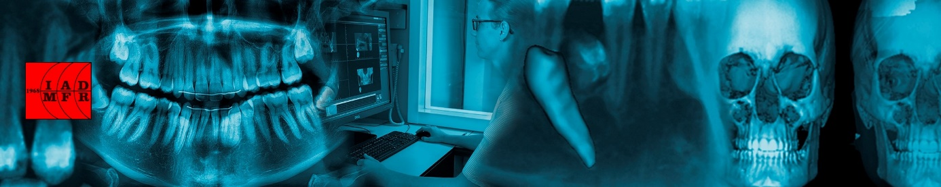

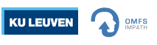 | Prof. Reinhilde Jacobs  Department of Imaging & Pathology  OMFS-IMPATH Research Group  KU Leuven – Group Biomedical Sciences  Oral and Maxillo-facial Surgery - UZ Leuven
reinhilde.jacobs@uzleuven.be | T:+32 16 332452 | F: + 32 16 332748
gbiomed.kuleuven.be/dep/DIP
Campus Sint-Rafaël | Kapucijnenvoer 33| BE-3000 Leuven

